STUDENT NUMBER: 2409-125289

STUDENT NAME: Vasile Bejan

Task 1

You have been given Network ID 192.168.20.0/24. Use FLSM subnetting for the network with 40 Hosts on each side.

Network Address | Usable Host Range | Broadcast Address
192.168.20.0 | 192.168.20.1 - 192.168.20.62 | 192.168.20.63
192.168.20.64 | 192.168.20.65 - 192.168.20.126 | 192.168.20.127
192.168.20.128 | 192.168.20.129 - 192.168.20.190 | 192.168.20.191

Fill in the missing details (IP Address, Broadcast IP, Subnet Mask, Default Gateway) in the IP Table List below.

Ensure you assign IP addresses to Computers, Servers, Serial and Fast Ethernet Ports and Routers.

Network - Subnet bits | DEVICE | IP address | Broadcast IP | Subnet Mask | Default Gateway
192.168.20.0/26 | PC1 – PC40 | 192.168.20.3 -  192.168.20.42 | 192.168.20.63 | 255.255.255.192 | 192.168.20.1
192.168.20.0/26 | Server (London) | 192.168.20.2 | 192.168.20.63 | 255.255.255.192 | 192.168.20.1
192.168.20.64/26 | PC41 – PC80 | 192.168.20.67 -  192.168.20.106 | 192.168.20.127 | 255.255.255.192 | 192.168.20.65
192.168.20.64/26 | Server (Rotherham) | 192.168.20.66 | 192.168.20.127 | 255.255.255.192 | 192.168.20.65
192.168.20.128/26 | Router 1 | 192.168.20.129 | 192.168.20.191 | 255.255.255.192 | N/A
192.168.20.128/26 | Router 2 | 192.168.20.130 | 192.168.20.191 | 255.255.255.192 | N/A

Task 2
Route the three (3) given networks using RIPv2 Dynamic Routing. And show the Router 1 and Router 2 routing configuration commands.

R1(config)# router rip
R1(config-router)# version 2
R1(config-router)# network 192.168.20.128
R1(config-router)# network 192.168.20.0

R2(config)# router rip
R2(config-router)# version 2
R2(config-router)# network 192.168.20.128
R2(config-router)# network 192.168.20.64

Task 3

Add the following services:
- FTP configuration for the Rotterdam server.
Username: cisco
Password: cisco
- HTTP and DNS configuration on the London server
London: adventureworks.com
- Email Server on Rotterdam site: adventureworks.com.
- Client (PC) Email Configuration on
PC1 assigned client1@adventureworks.com
PC40 assigned client40@adventureworks.com
PC41 assigned client41@adventureworks.com
PC80 assigned client80@adventureworks.com

- Windows Firewall rule to block outbound FTP (TCP port 21) for Rotterdam server.

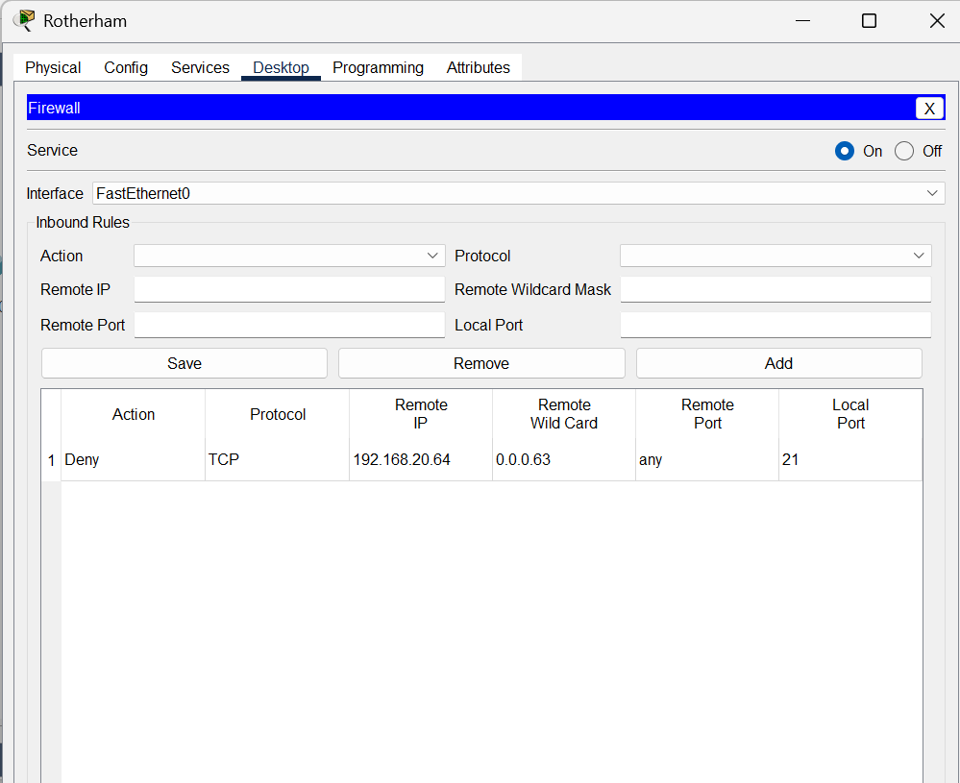

Task 4 (Screenshots)

Check all the connectivity (ICMP - ping) of all DTEs .

Print screen the tests such as tracert, HTTP (browser) testing, FTP testing, and Email (send/receive) testing.
- TRACERT (from PC1 to PC41)
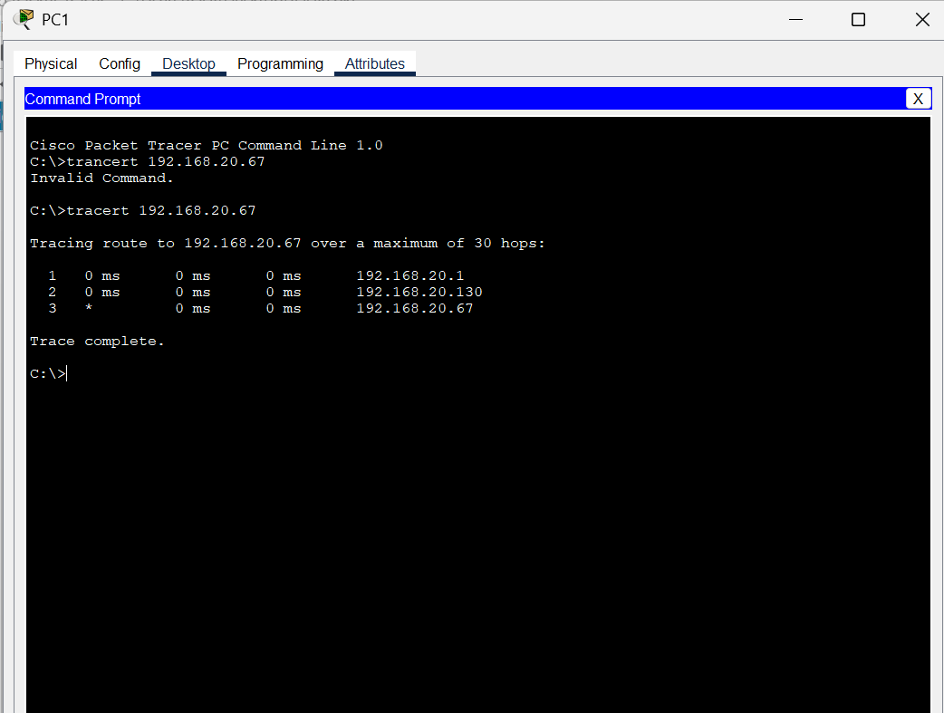

- TRACERT (from PC80 to PC40)

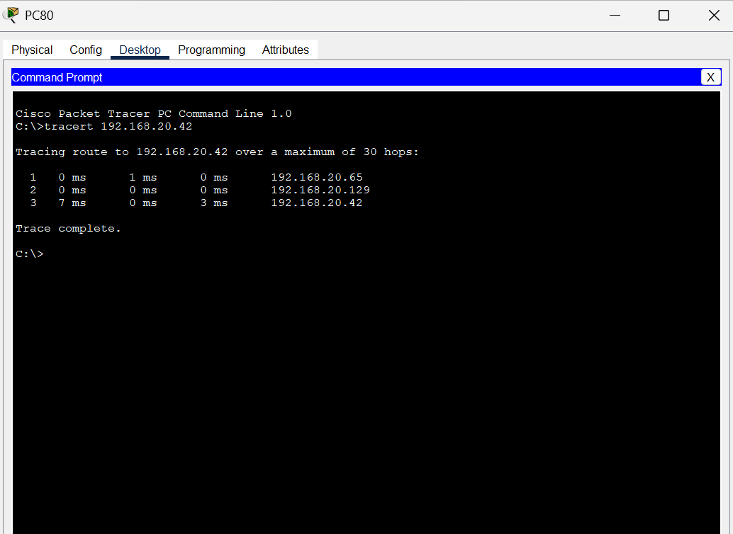

- TRACERT (from Rotterdam Server to London Server)
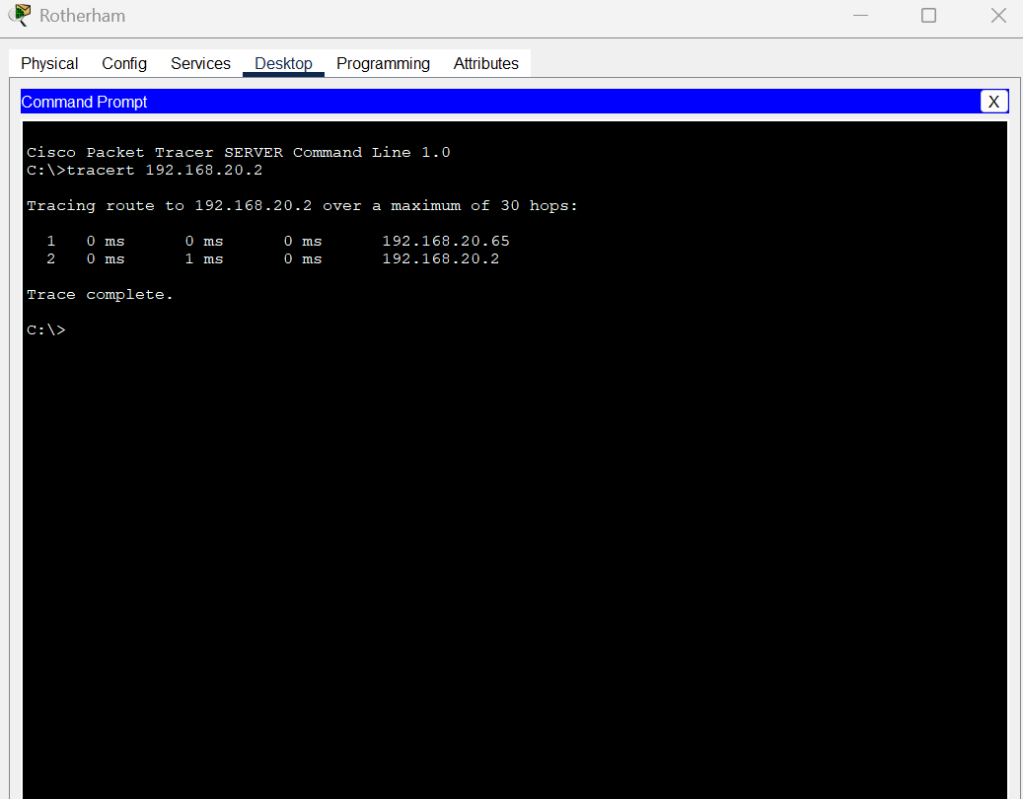

- HTTP (browser from PC1)
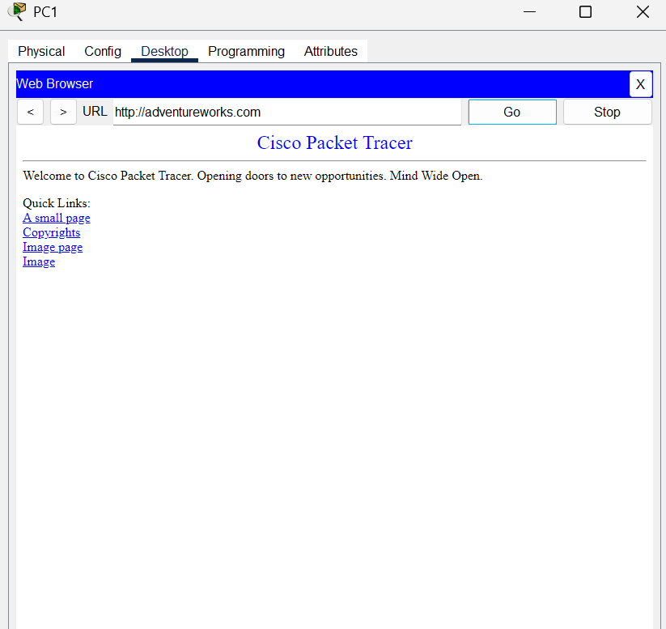

- HTTP (browser from PC80)

- FTP (access from PC40 to FTP server in Rotterdam)
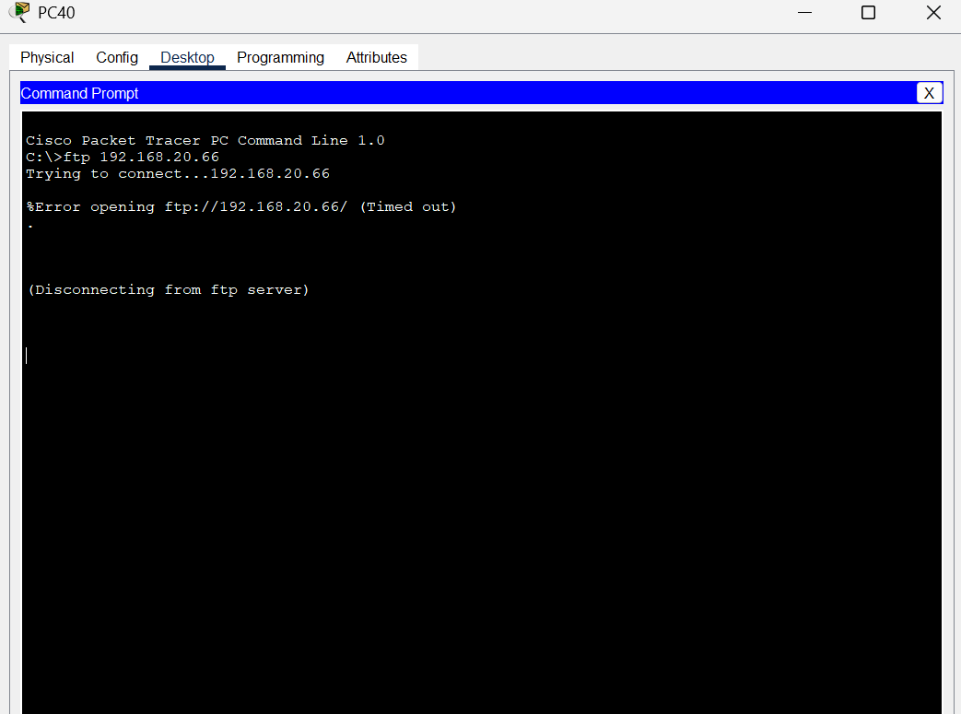

- FTP (access from PC80 to FTP server in Rotterdam)

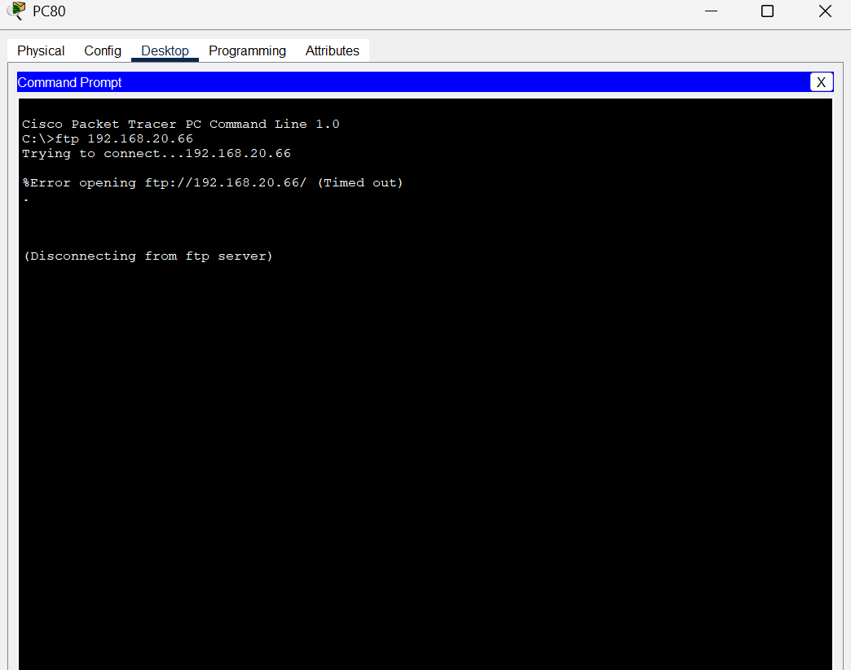

- Email – Send from PC1 to PC41. Provide screenshot of receiving side.
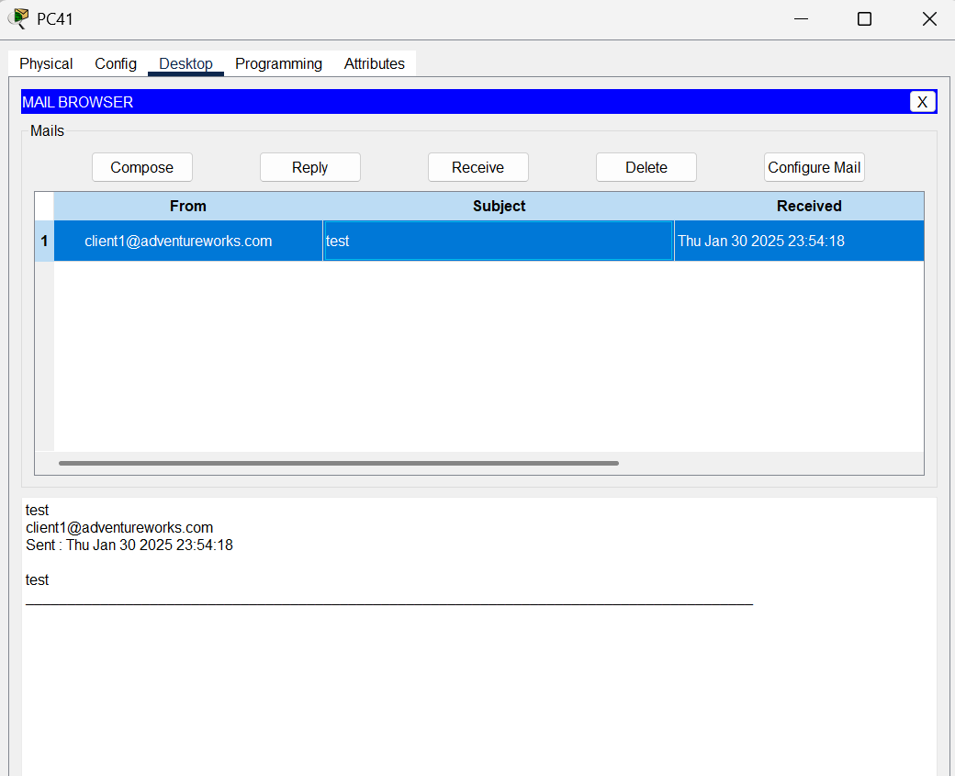

- Email – Send from PC80 to PC40. Provide screenshot of receiving side.
